1. Tuscany – Restaurant Shop Creative WordPress Theme

Tuscany – Restaurant Shop Creative WordPress Theme is a fully configurable and easy to use responsive WordPress theme with HTML5 Video Background Support and a lot of other great features. It is a perfect fit for the restaurants, pubs, bars, wineries and other companies offering foods and drinks.

Theme has modern and timeless design with many options to customize the final look of your website.

No matter what kind of content your website will contain, the template will take care of representing every single part of it in an elegant and professional way.

The HTML5 revolution is exciting for web designers from all areas of the globe. The new specifications support dozens of elements and attributes for building semantic websites. These new features include multimedia tags for audio and video formats. That’s why we have included full screen video support on Tuscany.

Designed for everyone, everywhere.

We have built the Tuscany on Bootstrap – the most popular HTML, CSS, and JS framework for developing responsive, mobile first projects on the web.

Bootstrap ships with vanilla CSS, but its source code utilizes the two most popular CSS preprocessors, Less and Sass. Quickly get started with precompiled CSS or build on the source.

Bootstrap easily and efficiently scales your websites and applications with a single code base, from phones to tablets to desktops with CSS media queries.

With Bootstrap, you get extensive and beautiful documentation for common HTML elements, dozens of custom HTML and CSS components, and awesome jQuery plugins.

Sell Anything with WooCommerce

WooCommerce is the most popular WordPress eCommerce plugin and it’s perfectly integrated into Tuscany WordPress theme. WooCommerce 2.0+ has been fully security audited by the leading WordPress security firm Sucuri to ensure it meets the highest WordPress security standards possible. Easily manage your simple, digital and variable products in WooCommerce with our intuitive UI. Assign Store Managers to handle the day to day management of your store. Use WooCommerce various methods including shipping classes to create intricate shipping rules. Configure comprehensive tax settings with tax classes and local tax rates.

1. Installing Tuscany

You can install the theme in two ways: through WordPress, or via FTP. The tuscany.zip file is the Installable WordPress Theme and what you need to use to get the theme installed. Please see the following sections for each method. But first, you need to download the Tuscany files from your Themeforest account. Navigate to your downloads tab on Themeforest and find Tuscany. Click the download button to see the two options. The Main Files and the Installable WordPress Theme.

WordPress Dashboard Installation

The easiest way to install your theme is via the WP Dashboard:

* Download your theme from your account’s Downloads page – This will download a compressed .zip file to your computer.
* On your website, go to Appearance > Themes > Add New > Upload Theme > Choose File to upload the tuscany.zip file.
* Click on Install Now to install the theme.
* Then go to Appearance > Themes to Activate the theme.

FTP Installation

* If you have FTP login details, you can upload the un-zipped file to the correct folder on your site.
* Download your theme from your account’s Downloads page – This will download a compressed .zip file to your computer.
* Extract this folder on your computer.
* Login to your site via FTP to upload the theme folder to the wp-content/themes/ folder.
* To Activate the theme go to your site WordPress Dashboard then to: Appearance > Themes.

Common Install Error: Are You Sure You Want To Do This?

If you get the “Are You Sure You Want To Do This” message when installing tuscany.zip file via WordPress, it means you have an upload file size limit. Install the theme via FTP if this happens, or call your hosting company and ask them to increase the limit.

Common Install Error: The theme is missing the style.css stylesheet.

A common issue that can occur with users new to installing WordPress themes is a “Broken theme and/or stylesheets missing” error message being displayed when trying to upload or activate the theme. This error message does not mean that the theme you have purchased is broken, it simply means it has been uploaded incorrectly. Luckily, there is a very easy fix. Please follow the steps below to rectify this issue.

* Download the final zip file from your downloads page.
* Unzip the final zip file; you should now have a final download folder.
* Do NOT upload the final download folder.
* Browse the contents and find the actual theme folder. If you look inside the theme folder, you will see a style.css file. This is how you know you have found the theme folder. This zip file is called tuscany.zip

1. Installing Tuscany Plugins, Importing Dummy Content & Theme Options

Installing Tuscany Plugins

Once you have installed and activated the theme, you will see a notification to install the necessary plugins. Here are the steps you will need to follow to install everything correctly:

* Click on the notification
* Select All Plugins and click on Install
* After the plugins are installed select them all once again and click on Activate

Importing Dummy Content & Theme Options

XML Import

We have created a folder labeled “Demo Content” which contains an export for the Live Preview. There are two files you need to import, the .xml file (the site content) and the .txt file (theme option settings).

* Go to Tools > Import > WordPress
* Install the WordPress import plugin
* Click Browse and import the XML file (dummy_content.xml)
* Check Import and Download Files if you want the images from the demo imported.
* Go to Theme Options > Import/Export
* Under Import Options click on Import from File and copy/paste the content of the theme_options.json file
* Click Save All Changes in your Options panel.
* After uploading the .xml and .json files all of your pages will show up in your main nav by default. To complete setup go to Appearance > Menus to setup your main menu navigation.
* The next thing you need to do is to go to Settings > Reading and choose your homepage. First you need to select Static Homepage and then you need to choose between your homepage templates.

1. Tuscany – Setting Up the Main Menu

WordPress comes with a wonderful and easy to use menus functionality, letting you quickly create a custom menu and place it in your theme’s supported menu areas or even in a widgetized area with the menus widget. By default WordPress, and our themes, will start by adding all of your pages to the default navigation menu. You can then customize your menu in all our themes by going to Appearance > Menus.

To setup a new menu, please follow the steps below. Its best to already have your pages created, even if they are blank pages.

Creating the Main Menu

* Navigate to Apperance > Menus page
* Click the “+” icon to make a new menu. Enter the name then hit Create Menu
* Your menu should be named Main Menu and you need to set it’s location as Primary Menu
* You can manage your menus using the drag and drop functionality. To create a dropdown menu, simply drag a menu item below and slightly to the right of another menu item and it will lock into place and create a dropdown section
* Once its all done, make sure you click the Save button.

While creating the menu you will need to think about the logo and in order to add it you will need to set up a menu item as a custom link with a logo-holder CSS class as it’s shown on the screenshot below:

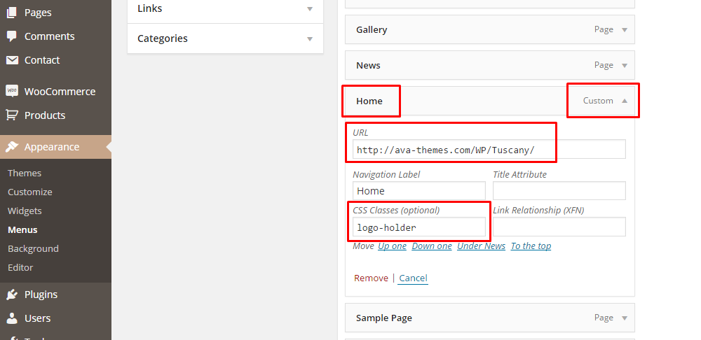

1. Tuscany – Front Page Setup

With Tuscany, you can have four different homepage versions:

* Homepage Main
* Homepage Video
* Homepage Woody
* Homepage Revolution

At this moment you cannot use sections from one homepage on another, but we are working on Visual Composer integration and we will have this feature ready for you by the end of January.

Now, in order to set up any of these homepage templates you need to go to **Pages > Add New** and under the Templates select the appropriate homepage template. After you publish the page you need to go to **Settings > Reading** and select Static Homepage. Under the dropdown please choose your homepage template according to the screenshots below:

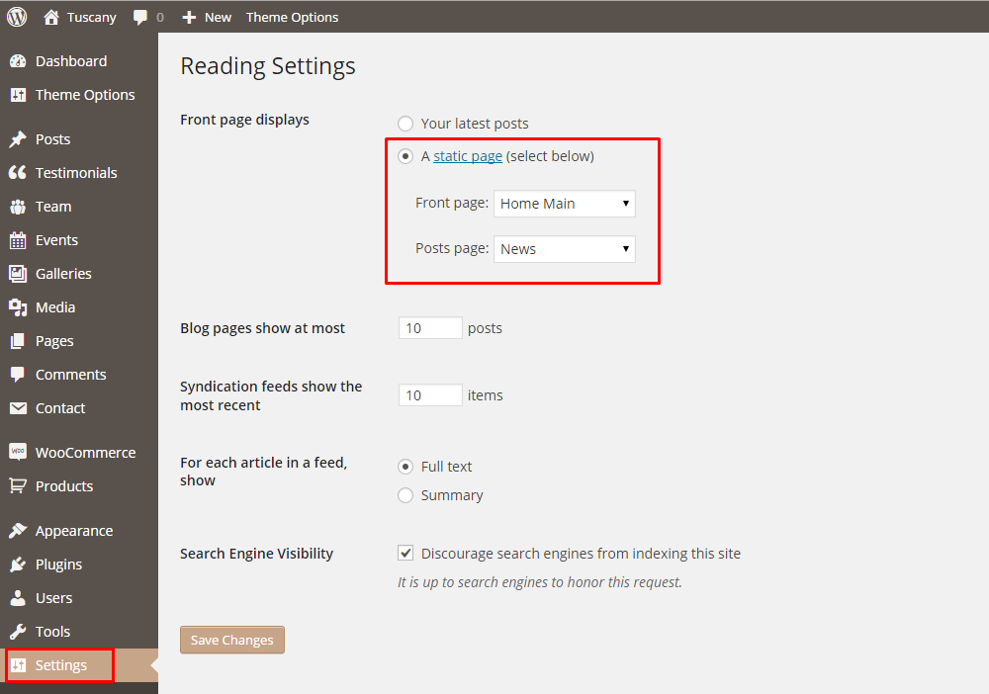

Once you do that, you will need to go to Theme Options to set up the rest of the homepage.

Theme Options > General Settings

One of the first things you will want to do is to add links for your social media profiles. In order to do that please go to **Theme Options > General Settings** and use the Social Icons drag and drop builder to set up your social media profiles:

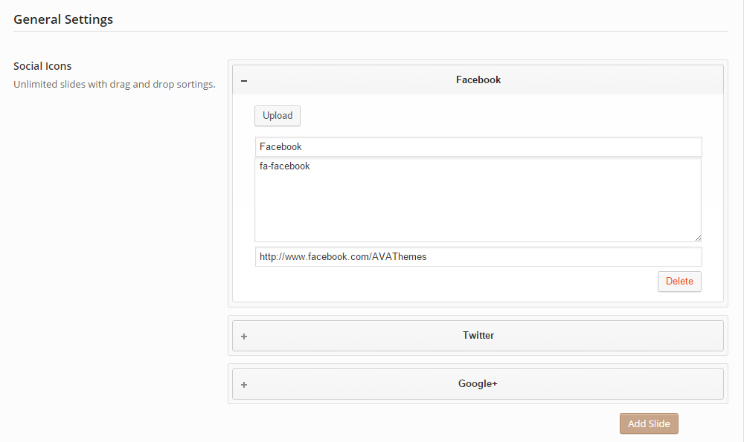

As you can see for every social network you need to add the title, code for the icon and the link for your profile. Code for the icon is actually a font code from Font Awesome.

As you can see you are able to add unlimited number of links by simply clicking on **Add Slide**. You can also delete any link you want by clicking **Delete**. In order to reorder the links / icons just just the pre built drag&drop feature and reorder the links as you want.

Uploading your logo

In order to upload your logo please go to **Theme Options > General Settings > Header Settings**.

Depending on what homepage template did you chose you will need to upload your logo on a specific page.

* If you chose Main Homepage or Revolution Homepage template than you will need to upload a dark PNG logo under the Logo section
* If you decided to go with Video Homepage template you will need to upload a light PNG logo under the Logo Light section
* And finally if you are using Woody Homepage template you will need to upload your logo under the Logo Ribbon section.

Changing Header background (Homepage Main or Homepage Revolution)

If you want to change the texture on your header go to **Theme Options > General Settings > Header Settings** and upload a pattern image under the Header Texture section.

Footer Settings

At this moment footer is not widget ready, but we are working on this feature and it will be available to you very soon. In order to set up your footer please go to **Theme Options > General Settings > Footer Settings** and enter all the necessary details.

Adding Video to Homepage Video Template

If you decided to go with the Video Homepage Templates, you will need to go to **Theme Options > Home Settings to add your video.** In the same place you will also be able to add the rest of the content that hoes over the video. Please see how we set it up:

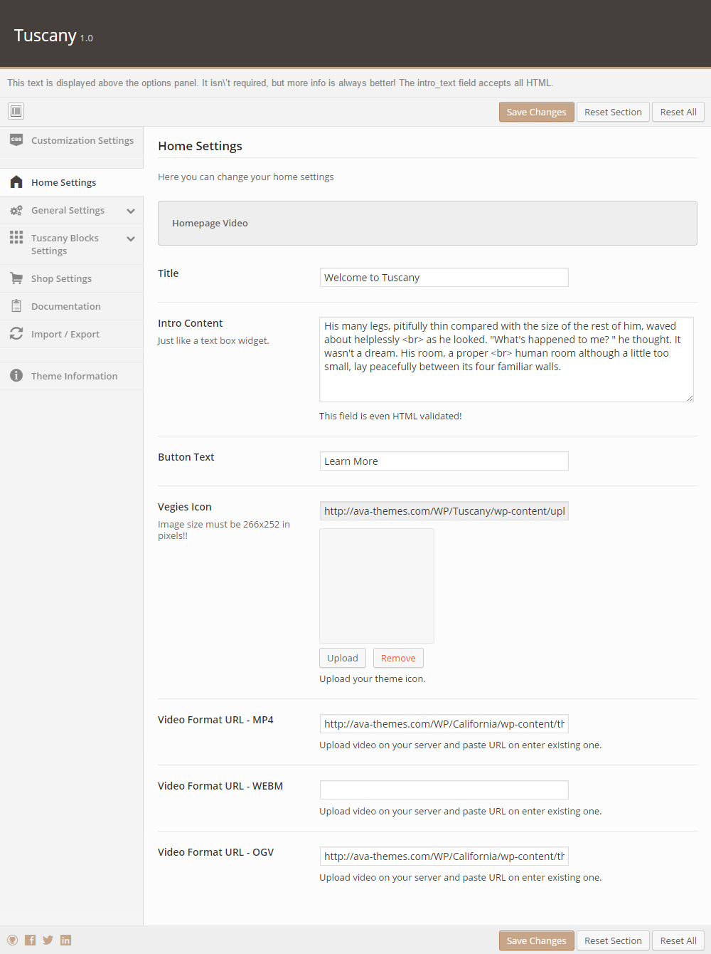

1. Tuscany Block Settings

Advertising Block

On the Main Homepage Template you will see this block:

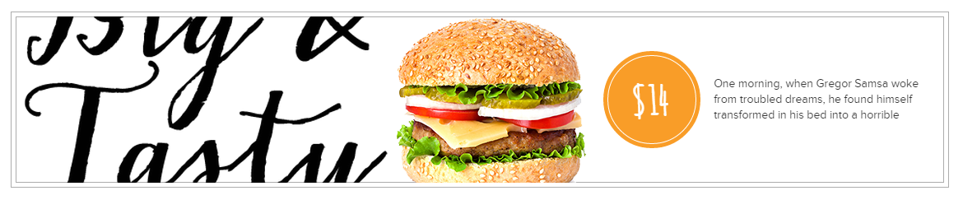

In order to set it up please navigate to Theme Options > Shop Settings and set it up like on the screenshot below:

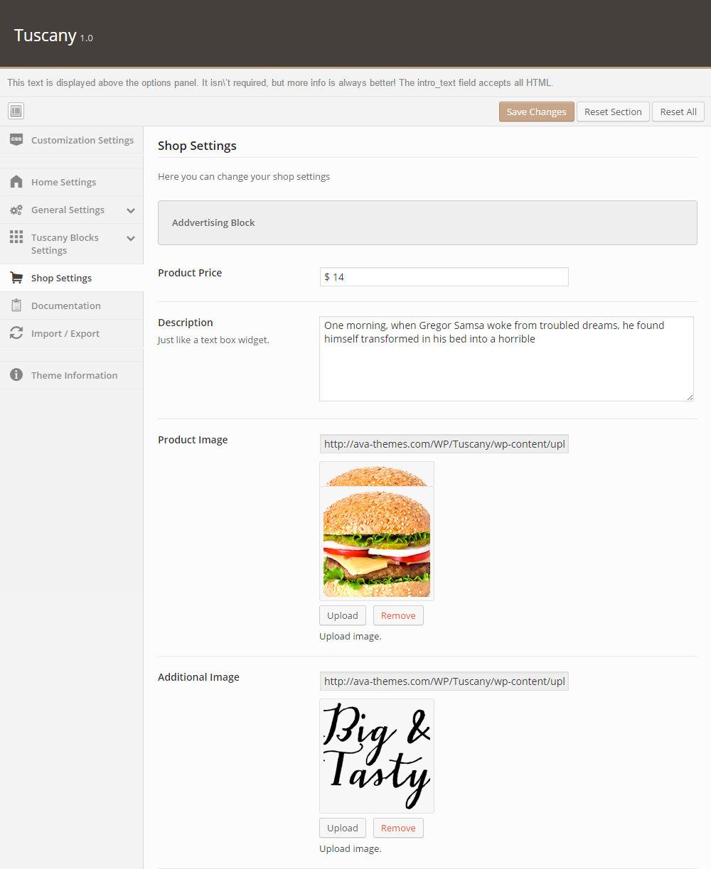

About Our Restaurant

On the Main Homepage Template you will see this block:

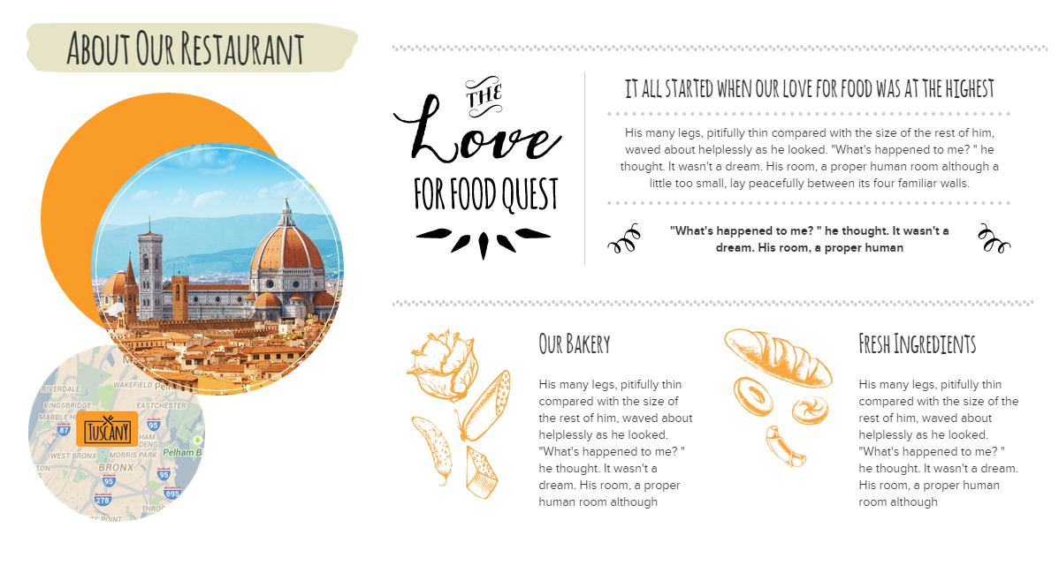

In order to set it up correctly please go to Theme Options > Tuscany Blocks Settings > About Additional Blocks and set it up like below:

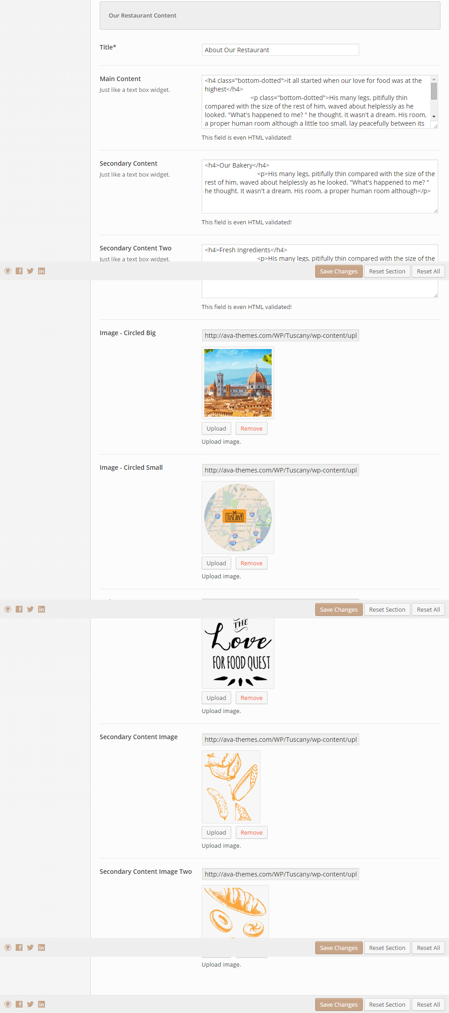

Our Menu

On the Main Homepage Template you will see this block:

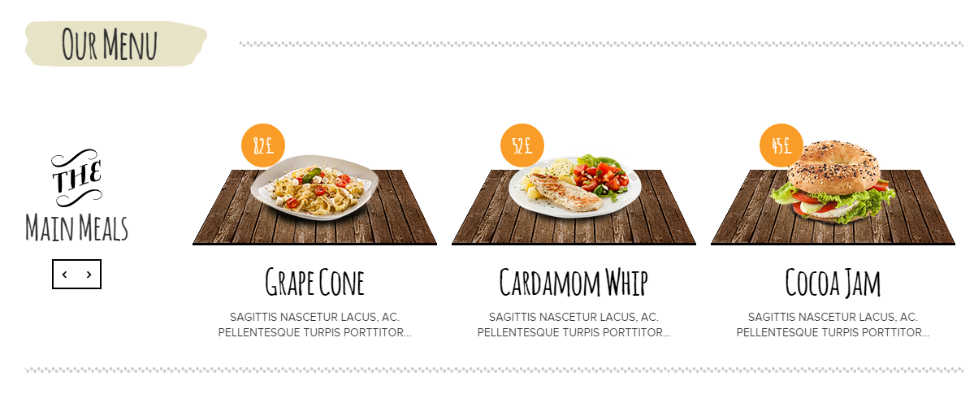

In order to set it up correctly please go to Theme Options > Shop Settings > Dishes Slider and set it up like below:

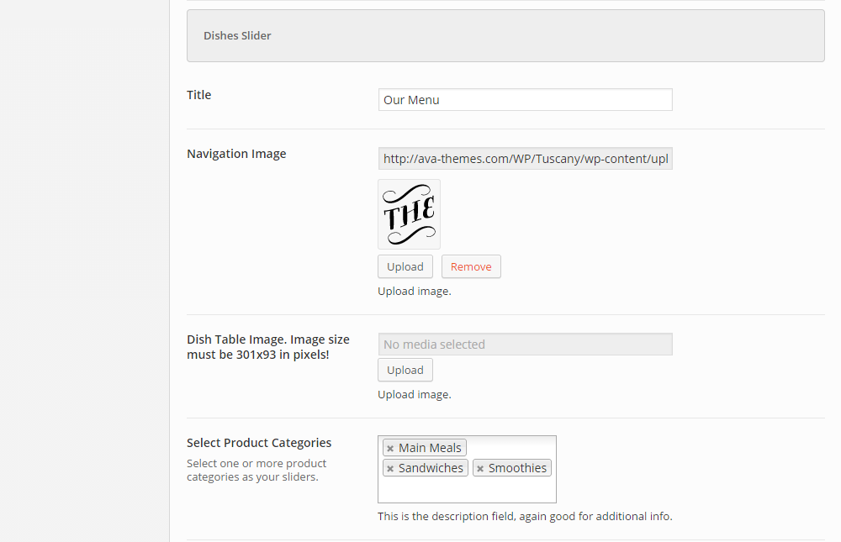

Gallery Block

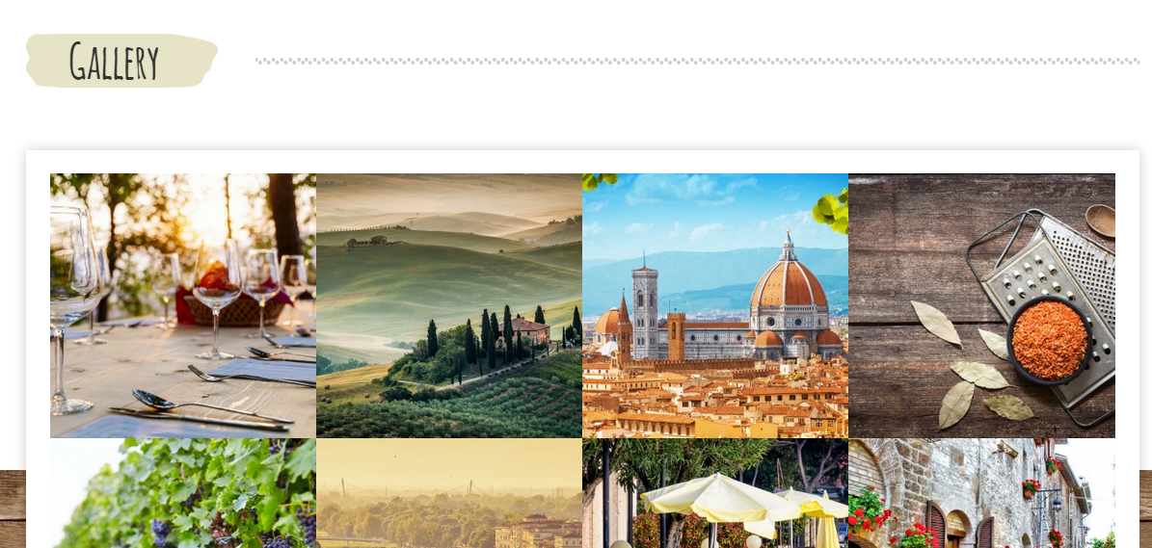

In order to set it up correctly please go to Theme Options > Tuscany Block Settings > Gallery and set it up like below:

